All
- I need to look at general fire news. For example, today there has been a fire in Turkey, I found the news, and I found the map data, then I matched them. Similarly, I can look at other countries.
- I should look at different flame or fire types from different sources, like twitter or news, and analyze how much the satellite is sure of itself
- Bursa wildfire, Antalya and Izmir wildfire
- May 15, 2026, Ukraine heavy bombardment.
- Go to reddit and find communities
- I will choose a few regions for parallel study. First Russia Ukrainian war, second Iran Israel war. I also consider choosing some other region that has wildfires like Australia. I need to determine time frames
- To match the news with the maps, I could take the locations of each subject country or city, and match the location with cities, countries or regions. So it will help me attach related news to the data points.
- To differentiate the other fires from war related heat activities, I could train a model that looks at the historical news and knows normal fire to war fire ratio, and then says this could be a war related event because in this area, war related fires are more common.
- What could be the specifications of war related fires and industrial, natural, and other fires. For example wildfires may cover large areas, they may last long, they may not start with sudden heat activities etc.
- I could make a website to present my work. It would have pages with the same order of the doc teacher sent.
- List of attacks during the 2026 Iran war - Wikipedia Here we have the affected countries by missiles. I will take those countries.
- List of ships attacked during the 2026 Iran war - Wikipedia Vessels hit
- Russian strikes against Ukrainian infrastructure - Wikipedia About russia ukraine war, it gives some dates
- EPSG:4326 is my map projection
- Api with country names only work in real time data. So I probably take the whole data for determined time period. Then will eliminate it by coordinates of Countries. I can create multiple country folders and keep their data in there
- To train the model, we take the times of war to reduce the workload
- https://krasnomovets.github.io/missile_calendar/missile-calendar.html found a website showing missile calender for ukraine
- I looked at a new data and checked it on FIRMS. A drone attack. But the data has very low frp value that could be a problem. Ukraine hits Russian energy targets and denies striking Kremlin-occupied nuclear plant
- GADM this website provides boundaries for the regions
- I think 3 words is the minimum barrier to match news with point

About NEWS
- Iran bombed Qatar, I could take time to match with satellite data
- Bursa wildfire, Antalya and Izmir wildfire
- May 15 2026, Ukraine heavy bombardment.
- Twelve day wars, Israeli hit the Iran facilities
- 10 october 2022, Ukraine bombardment Russian strikes against Ukrainian infrastructure - Wikipedia
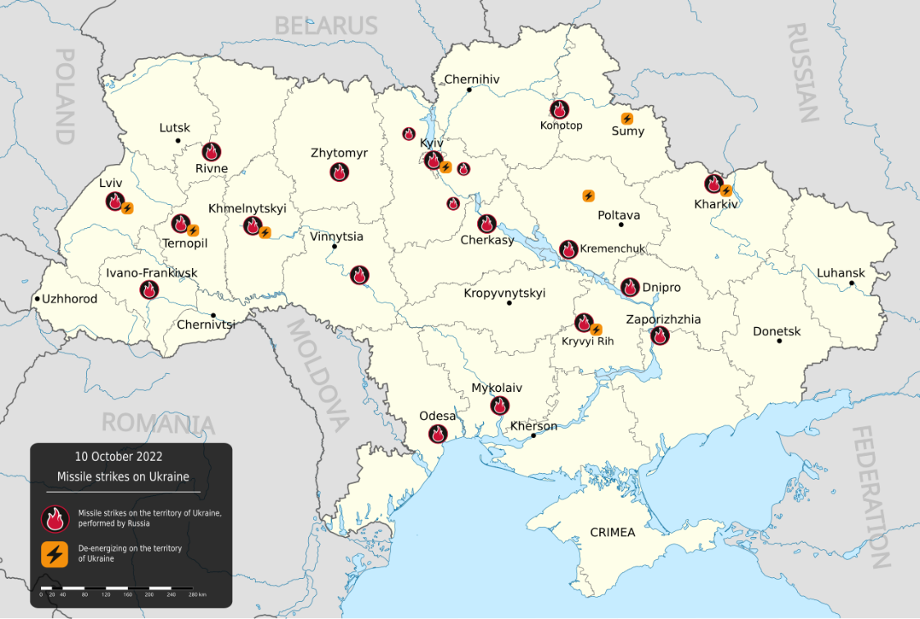
- https://en.wikipedia.org/wiki/Timeline_of_the_Russo-Ukrainian_war_(2022–present) This is for timeline.
- https://github.com/koala73/worldmonitor This guy made an open source app to accumulate geopolitical news.
- 5bb1fc46450d4d10929a61269910b9e6 news api https://newsapi.org/docs/endpoints/top-headlines
- 8fa62376-0756-4583-bbf4-a732a4c28c54 The Guardian api

Walkthroug
My options:
The Conflict & Maritime Zones (The Signal)
- Black Sea Basin: (Ukraine / Western Russia)
- Red Sea & Gulf of Aden: (Yemen / Western Saudi Arabia)
- Eastern Mediterranean / Levant: (Israel / Lebanon / Syria) Also could be Qatar, United Arab Emirates Saudi Arabia Qatar Bahrain Oman Kuwait Jordan Iraq Israel
The Baseline Zones (The Noise)
- Turkey: (Focusing on Marmara/Bursa and the Aegean/Mediterranean coasts)
- Australia (New South Wales/Victoria): forest fire
- Texas Permian Basin (USA): heavy industry and oil flaring
I chose Ukraine as my example country. For start, I took the 2022 from October 9 to 12 containing 3 days. Downloaded 3 satellite data for the boundary box I determined for each subject country, for Ukraine as starter. For the countries I've chosen, I determined a boundary box. Also I downloaded those data from GADM. I plan to make it for all cities and countries and regions. The reason I make such process to identify thermal points' location and match them with news correctly. For example, there are points in the kiev, but we don't know it at first, I apply the boundaries so we can now.
I determine The Guardian, NewsApi, for the api tools. I will try to scrap BBC, Google news, Bing news, The war zone, and The defence news. For the first step I will only take the data and make the operations later. I took the guardian data. At the end, I use googlenews, and warzone for scraping, and guardian, and nyt with api services. I need to clean and process those data. I cleaned and processed data.
I will download 5 days from 2020 for ukraine to see how not war situation effects. Also, i will use forest fires between 25 june 28 july in turkey https://tr.wikipedia.org/wiki/2025_Türkiye_orman_yangınları.
I will do thermal clustering in a new notebook. If the points are detected within 10 hours they are susceptible to clustering, it is observed. It will cluster the points satisfying criteria and gives centroid of clusters, maximum brightness, sum of all frps, maximum frp, earliest time of detection and latest time of detection, the duration in terms of hours, and centroid corresponding to the GADM area for each of those clustered points. Clustering will be after cleaning. The rows with missing values will be deleted. bright_ti4 is chosen to keep because it is similar to brightness by observation. After the cleaning I will have these columns: latitude,longitude,brightness,scan,track,acq_date,acq_time,satellite,confidence,bright_t31,frp,daynight,area_label,bright_ti4
There are different conditions for different satellites, modis and viirs. I can look at:
- Modis: i can cluster with 2km, because it generates 1km pixels, maybe one point could just fall between exactly two pixels. Confidence will be higher than 75. Frp will be higher than 20
- Viirs: cluster with 800m. Not take confidence ‘l’. Frp will be higher than 5
I cleaned the data and mapped it, it seems like forest fires have frp values more than 50 for Modis. Also i checked the map images and using only frp could be more useful because brightness does not give that much clue
Now Im using 6 month data for ukraine. Also have 35 days data for turkey, mainly composed of forrest fire. I have six month news data, this is for ukraine. I should find a way to interact news and thermal data in a way so that I could eliminate some illogical points from the map. But how?
—
How i do news and thermal events matching: In one side, i have thermal events, lets say for ukraine, covering 6 months period. On the other side i have news for that period. I just made a preliminary cleaning and left other data. There are data with low values too. To match the news, the code should look at the thermal points and news and make the first matching with date. I think 24 hours latency is enough for connection between point and news. If there is at most 24 hour match, the code will give it a score, for near match like 1 hour or immediate, the score will be higher. The date is first step for training. If there is no match with news, those points will get no points. When There is a matched news, second step is to look at how much key word is matched. I want to derive different logics in here. There will be key words for wildfire and forrest fire, and keywords for war and missile attacks. At least one word related to explosion or bombardment, and other 3 war related words are required. If matched news has lower keywords marched, they get minimum point, and that point is given because there is a news matched. The grade will higher if matching words are higher. If the area, city for example, name is in the word, then it will give additional grade, because both time, area, and content match could be a strong indicator.
—
After the matching and finding reliable points, i will do ML classification with two chosen ML model. But first it would be better to increase training data by adding all middle east into the data. Also add new keywords for wildfire and war in more detail
For fire:
- 2021 07 - 2021 10 turkiye https://tr.wikipedia.org/wiki/2021_Türkiye_orman_yangınları
- 2025 06 - 2025 09 turkiye https://tr.wikipedia.org/wiki/2025_Türkiye_orman_yangınları
- 2019 - 2020 Australia https://tr.wikipedia.org/wiki/2019-2020_Avustralya_orman_yangınları
For war:
- Iran 2026
- Israel 2026
- Qatar 2026
- Uae 2026
- Ukraine 2022 10 - 2024 06
When I operating on big data, like whole year of australia, it take too much time. So I removed it.
Future Works
- One fix could be taking all news data as raw rather than filtering it, and process it late. Because we should give keywords carefully otherwise it wont fetch. But take it and process later is a better approach. It gives more flexibility
- One remark, region names in news and those in source data could differ and that affects the news correlations, so there should be a few options for each area names
- There is something happened in sanliurfa, but they are not continuous. There are news for small filed fires. But Kahramanmaras/cakirdere (https://www.instagram.com/reel/DMp-3AGJ2XB/ ) , Bursa, Osmaneli/kiziloz (https://www.instagram.com/reel/DMabcWUouui/ ), Ankara/eymir (https://ankaragolbasi.bel.tr/haberler/eymir-golu-cevresinde-cikan-yangin-kontrol-altina-alindi-62741 ), Izmir, Antalya show some duration, some more than 12 hour, some more than a few hours. They are susceptible to be a wildifre.
- When there are more than one point exist on the map at the same date, news are matched with all. That is a problem because, some false points may not be eliminated in the cleaning process
- To have an idea about the coverage of fire, we could use scan and other xolumn of FIRMS. They give approximate area of each point. When clustrated, they will give large area. İf it is bigger tgan a trashold, we can say it is a wildfire.
- Vessel hits are very few. At most 60 maybe. They can be inserted to model by memorizing data maybe

